SQLConnector pseudocode

1. Connecting to the database using

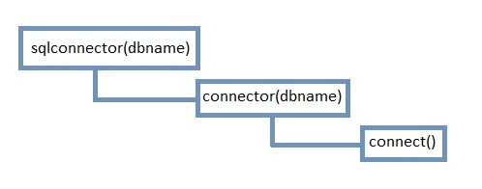

1. Executing SQL query using *ResultSet runquery(query)* method
2. Update SQL database using *Update(query)* method
3. Create SQLite client database

* Creating c*lientdb* database
* Creating peersarray table
* Creating *clientswarm* table
* Creating *clientpeers* table

1. Close connection to the database